# INTRODUCTION

## Overview

Climate change continues to be a critical global challenge, with carbon emissions playing a significant role in environmental degradation. The carbon credit system was developed as a market-based approach to reduce greenhouse gas emissions. However, current implementations suffer from centralization, limited transparency, and inefficient validation mechanisms. Addressing these challenges, this project presents a blockchain-driven solution that leverages smart contracts to enhance the credibility, efficiency, and transparency of carbon credit trading.

This report outlines a blockchain-based carbon credit ecosystem developed using the Ethereum platform. By implementing ERC-1155 tokens for fractional carbon credit representation, integrating a multi- signature verification model, and deploying an Automated Market Maker (AMM) for decentralized trading, the system enables a more streamlined and accountable approach. The architecture also employs off-chain storage via MongoDB to manage scalability in user data handling. Initial testing on Ethereum testnets validates the system's capacity to process and settle transactions significantly faster than traditional methods, while also supporting integration with leading standards such as Verra and Gold Standard.

To further enhance the system's robustness and real-world applicability, this project is actively developing a functional prototype that integrates remote sensing data for automated carbon credit estimation. A key innovation involves incorporating **Normalized Difference Vegetation Index (NDVI)** values derived from **Sentinel-2 satellite imagery** to assess carbon sequestration potential in forestry and agricultural projects. By processing NDVI data through machine learning models, the system can dynamically estimate carbon absorption rates, ensuring more accurate and verifiable credit allocation. This approach reduces reliance on manual audits while improving scalability for large-scale reforestation and conservation initiatives. The prototype will feature a geospatial dashboard where project developers can submit land-based carbon sequestration claims, which are then cross-verified against historical NDVI trends and blockchain-stored validation results.

## Motivation

The traditional carbon credit market is burdened with several inefficiencies, such as centralized control by intermediaries, manual and time-consuming verification processes, and a lack of price transparency. These issues hinder participation and trust in climate finance mechanisms. As global carbon markets expand, there is a growing need for a transparent, tamper-proof, and decentralized system that allows secure, real-time transactions and verifiable credit validation.

Blockchain technology offers a compelling solution by enabling immutable, decentralized record- keeping and programmable automation via smart contracts. Motivated by these advantages, this project seeks to design and implement a blockchain-based carbon credit system that empowers stakeholders, accelerates verification, and improves market liquidity. This approach aligns with the broader goals of enhancing climate finance mechanisms and supporting environmental sustainability through digital innovation.

## Objectives

* + - To develop a decentralized and transparent carbon credit trading platform that leverages blockchain technology to enhance trust, efficiency, and accessibility.
    - To automate the lifecycle of carbon credits—including issuance, validation, trading, and retirement—through the use of Ethereum smart contracts.
    - Implementation of ERC tokens, enabling fractional ownership and flexible integration with established carbon credit standards such as Verra and Gold Standard.
    - To ensure the integrity and reliability of credit verification, a multi-signature mechanism has been incorporated, allowing multiple authorized stakeholders to participate in consensus-based validation.
    - To handle scalability and data efficiency, the architecture integrates on-chain operations for core functions with off-chain storage solutions using MongoDB for user data.
    - To build a technically robust, policy-aligned framework that could facilitate broader adoption of blockchain in climate finance initiatives.

# LITERATURE SURVEY

|  |  |  |  |  |
| --- | --- | --- | --- | --- |
| **Sr.no** | **Title** | **Author** | **Year** | **Description** |
| 1. | A  Blockchain-based Carbon Credit Ecosystem | Dr. Soheil Saraji,  Dr. Mike Borowczak | 2023 | **Overview:**  This research explores how blockchain technology can enhance transparency, trust, and operational efficiency in carbon credit markets. By leveraging smart contracts and tokenization, the proposed ecosystem enables the digital representation and standardized trading of carbon credits, aiming to streamline transactions and minimize associated costs. |
| **Advancements:**  Blockchain can reduce over- crediting and double-spending, while tokenizing carbon credits for seamless trading. |
| 2. | Leveraging Blockchain in Energy Transition and Decarbonization | Dr. Surekha Deshmukh | 2022 | **Overview:**  This paper delves into the potential o blockchain technology to accelerate the global energy transition and support decarbonization efforts. Key applications discussed include peer-to peer energy trading, where consumers can directly exchange surplus energy the use of smart contracts to automate and enforce energy transactions; and optimization of energy grids through real-time data sharing and improved coordination between producers consumers, and grid operators. |
| **Advancements:**  Focuses on enhancing transparency and accountability in decarbonization efforts and utility ecosystem management using  digital tools like AI and blockchain. |

|  |  |  |  |  |
| --- | --- | --- | --- | --- |
| 3. | A Digital  Carbon | Infosys Limited | 2020 | **Overview:**  The paper proposes leveraging |
| Credits | blockchain technology to overcome |
| Ecosyste | the fragmented and inefficient |
| m, | structure of existing carbon markets. |
| Powered | By creating a unified, decentralized |
| by | platform, blockchain can bring |
| Blockchai | transparency, traceability, and |
| n | standardization to the entire carbon |
|  | credit ecosystem. This includes the |
|  | issuance of verified credits, seamless |
|  | peer-to-peer trading, and end-to-end |
|  | lifecycle tracking—from project |
|  | registration and validation to |
|  | retirement of credits. The approach |
|  | aims to build trust among |
|  | stakeholders, reduce administrative |
|  | overhead, and ensure accountability |
|  | in carbon offset processes. |
|  | **Advancements:** |
|  | Blockchain can standardize carbon |
|  | credit pricing, enhance transparency, |
|  | and reduce transaction costs by |
|  | eliminating intermediaries |
| 4. | Blockchain of Carbon Trading for UN  Sustainable Development Goals | Seong-Kyu Kim, Jun- Ho Huh | 2022 | **Overview:**  This paper focuses on applying blockchain to measure and verify carbon credits aligned with the UN Sustainable Development Goals (SDGs). It suggests using AI and big data for anomaly detection and trading verification. |
| **Advancements:** |
| The blockchain-based verification system can enhance transparency and reduce fraud in carbon trading. |

**Fig 2.1 Related Work**

# SYSTEM DESIGN

## Problem Statement

To address the critical challenges in traditional carbon credit markets—including fraud vulnerabilities, high operational costs, and inefficient verification processes—this project proposes a decentralized blockchain-based solution. The current system's lack of transparency and reliance on intermediaries hinder trust and broad participation, ultimately limiting its effectiveness in combating climate change. Our approach leverages smart contracts and ERC tokenization to automate credit validation and issuance, while an Automated Market Maker (AMM) ensures liquidity and real-time trading. By integrating these technologies, the system minimizes fraud, reduces transaction costs, and establishes a scalable, transparent, and sustainable framework for global carbon markets

## Overview of the Proposed System

The proposed blockchain-based carbon credit ecosystem aims to create a secure, transparent, and efficient platform for managing carbon credits throughout their lifecycle—from issuance to trading and retirement. The system digitizes carbon credits as blockchain tokens, enabling real-time tracking and automated execution of transactions via smart contracts. This approach facilitates trust among participants by ensuring data integrity and minimizing the need for intermediaries.

## System Architecture

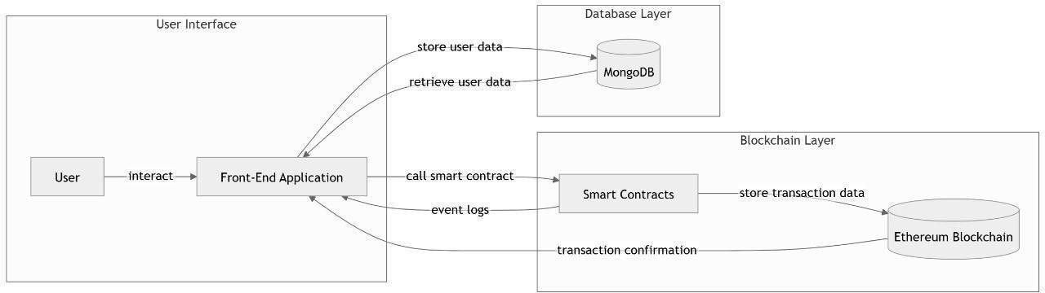

**Fig 3.3.1 Three-tier system architecture**

The proposed blockchain-based carbon credit ecosystem is implemented using a **three-tier architecture**, which separates the system into the following layers:

### Presentation Layer (Frontend)

* + This layer consists of a **React.js** based web application that serves as the user interface.
  + Users such as carbon credit generators, validators, government authorities, and buyers interact with the system through this interface.
  + It handles user inputs, displays data, and communicates with the blockchain network and backend services.

### Business Logic Layer (Blockchain Layer)

* + The core functionality is implemented using **four smart contracts deployed on a local Ethereum blockchain (Ganache)**:
    - **MintCCT Contract:** Manages the issuance and lifecycle of carbon credit tokens.
    - **MintNFT Contract:** Generates non-fungible tokens for retirement certificates.
    - **AMM Contract:** Provides an Automated Market Maker for token trading and liquidity provision.
    - **MultiValidator Contract:** Handles multi-signature validation and approval workflows to ensure project authenticity.
  + These contracts automate transactions, enforce rules, and maintain the immutable ledger of carbon credit activities.

### Data Layer (Off-chain Database)

* Due to the large size and privacy concerns of project documents and verification data, an

**off-chain MongoDB database** is used for storage.

* The smart contracts interact with this off-chain data indirectly via transaction metadata and frontend synchronization.

This 3-tier architecture enables a modular, scalable, and secure carbon credit ecosystem where the frontend offers usability, the blockchain layer guarantees transparency and trust, and the off- chain database ensures efficient data management.

## Process Flow

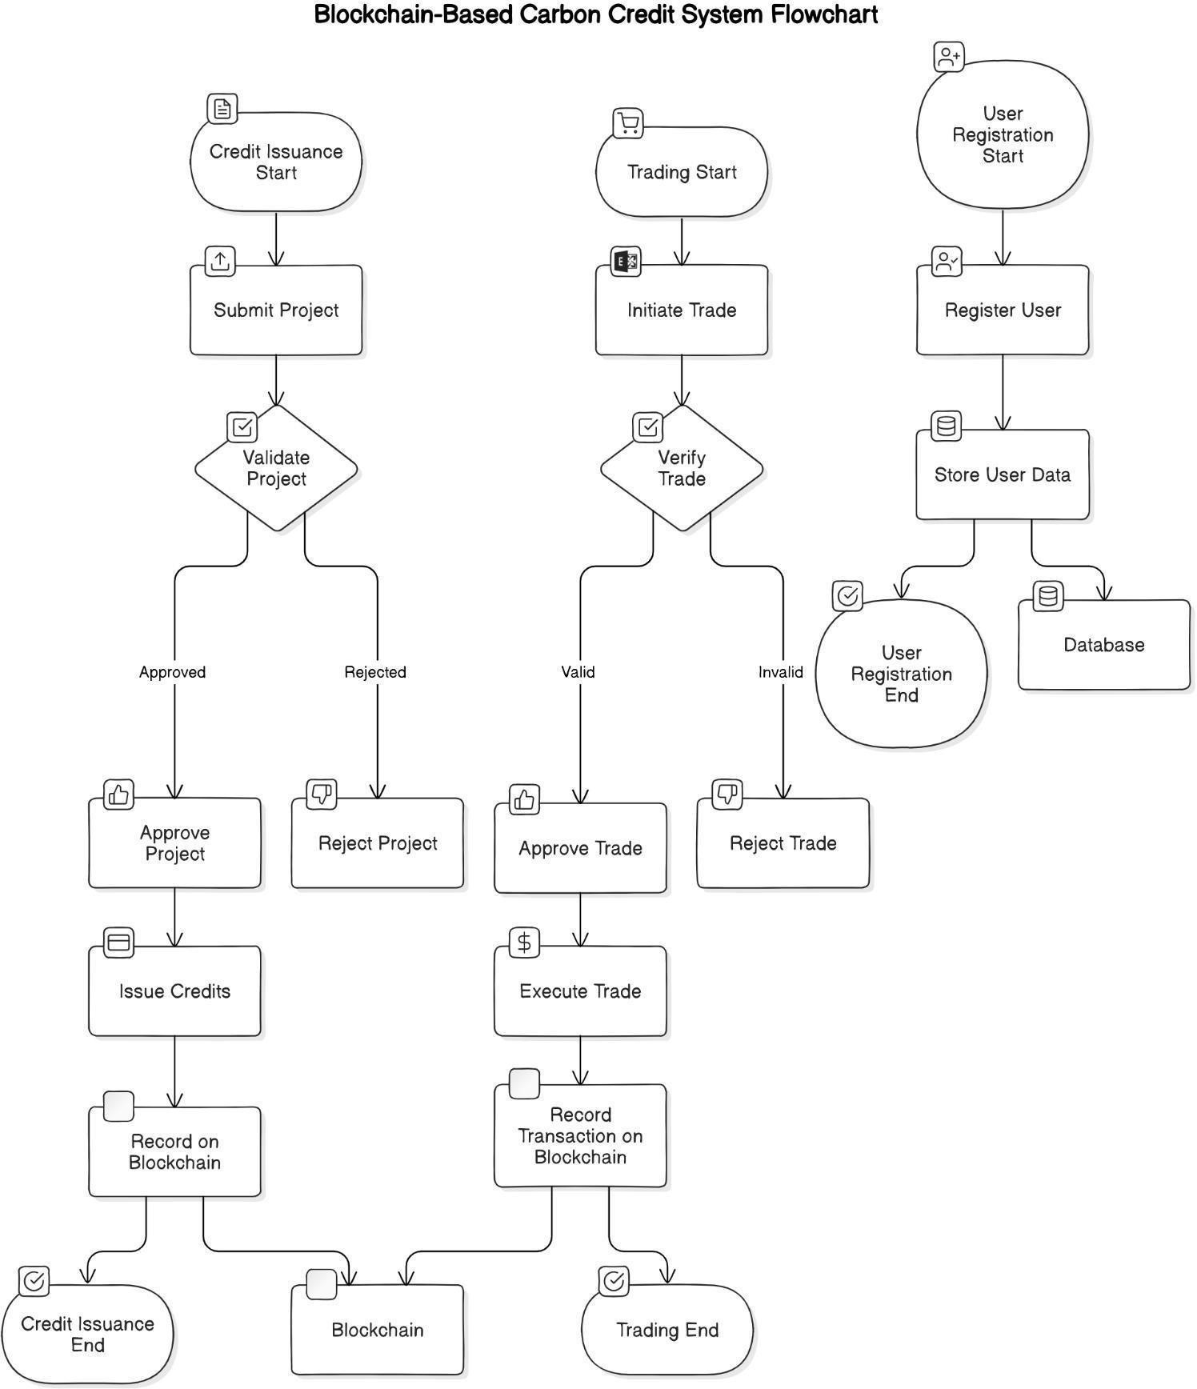

**Fig 3.4.1 Flowchart**

The system involves three primary stakeholder groups that play distinct roles in the carbon credit ecosystem:

### Carbon Credit Generators:

This group primarily includes **farmers, industries, NGOs, and other project developers** who actively work on carbon reduction or removal projects. They collect and upload proof of carbon offset activities, such as satellite NDVI data, documentation, and other evidence demonstrating their efforts to reduce emissions or enhance carbon sequestration. Their role is critical as they initiate the carbon credit issuance process by providing verified data.

### Validators and Multi-signature Authorities:

Validators are responsible for rigorously reviewing and verifying the authenticity and accuracy of the submitted project data. This includes cross-checking satellite imagery, documents, and compliance with regulatory standards. Multi-signature authorities typically include representatives from government bodies, decentralized autonomous organizations (DAOs), or appointed NGOs who jointly approve credit issuance through a multi-signature smart contract process. This layered validation ensures the legitimacy and trustworthiness of the carbon credits issued.

### Consumers and Buyers:

These stakeholders mainly include **industries and companies** that emit carbon and seek to offset their footprint by purchasing carbon credits. Upon retirement of these credits, consumers receive blockchain-based carbon removal certificates as proof of their contribution to decarbonization.

They participate in trading carbon tokens and driving demand for verified carbon offsets within the ecosystem.

The following steps outline the key processes involved in the lifecycle of carbon credits within the blockchain-based ecosystem, ensuring transparency, trust, and efficiency at every stage.

### Credit Issuance

This phase initiates the creation of carbon credits based on verified carbon reduction projects.

* + Carbon credit generators, including farmers, industries, and NGOs, submit comprehensive proof of their carbon reduction activities through the frontend interface.
  + Validators rigorously assess the submitted evidence, such as NDVI satellite imagery and related documentation, to ensure accuracy and compliance with standards.
  + Verified data is securely stored in the off-chain MongoDB database to maintain privacy while supporting scalability.
  + Multi-signature authorities, consisting of government representatives, DAO members, and NGOs, collectively review and approve the issuance request using a multi-signature smart contract.
  + Following approval, the MintCCT smart contract mints carbon credit tokens on the blockchain, officially recognizing the verified carbon offsets.

### Trading

Once carbon credits are minted, they become tradable digital assets that enable a dynamic market for offsetting emissions.

* + Carbon credit tokens are listed on the Automated Market Maker (AMM) platform, facilitating decentralized and transparent trading.
  + Liquidity providers supply funds to the AMM to ensure smooth trading and price stability.
  + Buyers, primarily industries aiming to reduce their carbon footprint, can purchase and trade tokens securely on-chain, promoting a liquid and efficient marketplace.

### Retirement

Retiring carbon credits is the process by which buyers permanently remove tokens from circulation to claim carbon offset benefits.

* + When a buyer chooses to retire tokens, the smart contract burns (destroys) the corresponding carbon credit tokens on the blockchain.
  + The MintNFT smart contract generates a unique, immutable retirement certificate as a non- fungible token (NFT) that serves as proof of offset.
  + The retirement information is updated in the off-chain database, maintaining a transparent, auditable record of carbon credit retirement activities

# SYSTEM REQUIREMENTS

## Functional Requirements

### User Registration and Login

The system allows users (such as carbon credit generators and validators) to register and log in securely using email and password authentication, ensuring authorized access to the dashboard and functionalities.

### Wallet Integration with MetaMask

Users must connect their Ethereum-compatible wallet (e.g., MetaMask) to interact with blockchain- based functionalities such as token minting, trading, and retirement.

### NDVI Submission and Viewing

Generators can select coordinates and submit NDVI data from satellite sources (like Sentinel Hub). NDVI values are displayed and logged for verification and carbon estimation.

### Validator Dashboard and Verification

Validators can access a dedicated dashboard where they receive submitted NDVI and project data, verify its authenticity, and approve or reject based on set criteria.

### Multi-Signature Approval Process

A multi-signature smart contract ensures that at least a threshold number of validators or authorities approve a project before carbon credits are minted, enhancing governance and preventing fraud.

### Carbon Credit Minting

Upon successful validation and multi-signature approval, ERC-1155 carbon credit tokens are minted via the MintCCT smart contract and assigned to the generator’s wallet.

### Token Trading (AMM)

Carbon credit tokens can be traded on a decentralized Automated Market Maker (AMM) platform. Users can swap tokens with ETH or other tokens, with price discovery handled via a constant product formula.

### Retirement and NFT Generation

When a user decides to retire carbon credits, the corresponding tokens are burned and a non-fungible retirement certificate (NFT) is issued via the MintNFT contract, ensuring proof of carbon offset.

### Transaction Logging and Event Handling

Smart contract events such as minting, trading, or retirement are captured in real time and reflected on the frontend to ensure transparency and immediate feedback to users.

## Non-Functional Requirements

### Scalability

The system is designed using a modular architecture, ensuring it can scale to accommodate more users, validators, and transactions without significant performance loss.

### Security

Blockchain integration ensures immutability and transaction integrity. Additionally, multi-signature contracts and wallet authentication enhance system security.

### Usability

A clean and responsive React.js frontend ensures the application is easy to use for both technical and non-technical users, including farmers and industry stakeholders.

### Performance

Smart contract interactions and database queries are optimized to reduce latency and ensure smooth user experiences even under load.

### Reliability

The system ensures high availability of services such as NDVI verification and token operations, with fail-safes for network disconnection and contract fallback functions.

### Maintainability

Code is modular, version-controlled, and documented to facilitate easy updates and bug fixes.

## Hardware Requirements

### Minimum System Configuration for Development

* + Processor: Intel Core i3 or equivalent
  + RAM: 4 GB
  + Storage: 500 GB HDD
  + Internet connection (minimum 2 Mbps)

### Recommended System Configuration

* + Processor: Intel Core i5/i7 or AMD Ryzen
  + RAM: 8–16 GB
  + Storage: 256 GB SSD or higher
  + Stable broadband internet connection (5+ Mbps)

## Software Requirements

### Development Tools

* + Node.js and npm (for backend and package management)
  + React.js (for frontend development)
  + Truffle Suite (for compiling, deploying, and testing smart contracts)
  + Solidity (language for smart contracts)

### Blockchain Environment

* + Ganache CLI or GUI for local blockchain simulation
  + MetaMask browser extension for wallet interaction

### Database

* + MongoDB for storing off-chain data such as project documents, NDVI records, and user profiles

### Supporting Libraries

* + Web3.js: Interface for frontend and smart contracts
  + Express.js: Backend server handling REST API and WebSocket connections

## Network Requirements

### Internet Connectivity

A stable internet connection is essential for wallet interactions, satellite NDVI fetching, and on-chain operations.

### WebSocket Support for Real-Time Data

The system uses WebSockets to send NDVI and validation messages in real-time between generator and validator dashboards.

### Access to Ethereum Testnet or Ganache

Required for testing smart contracts in a controlled environment before mainnet deployment.

# SYSTEM IMPLEMENTATION

## Technologies Used

The development of the blockchain-based carbon credit ecosystem utilized a full-stack set of technologies that ensured decentralized operations, seamless user interaction, and scalable off-chain data management. The key technologies are as follows:

### React.js

Used for building the **frontend user interface**. React enabled a dynamic and responsive web experience where users can interact with the system to submit carbon reduction data, track token status, and perform blockchain transactions in real-time.



### Solidity

The core **smart contract logic** was written in Solidity. It powers all blockchain operations, including carbon credit minting, validation, trading via AMM, multi-signature approvals, and retirement through NFTs.



### Truffle Suite & Ganache CLI

Used for **compiling, testing, and deploying** Solidity smart contracts. Truffle simplifies contract migration and offers a structured environment for automated testing.

A local **Ethereum test network** used for deploying and testing smart contracts during development. Ganache CLI simulates blockchain behavior, allowing full control over accounts, balances, and block mining.



### MetaMask Wallet

MetaMask acts as the **user-side wallet**, enabling users to connect to the Ganache test network and sign blockchain transactions securely from the browser.



### Web3.js

A **JavaScript library** that facilitates interaction between the React frontend and deployed smart contracts on the Ethereum blockchain. It allows the frontend to read data from and write transactions to the blockchain.

### Node.js with Express.js

Used to build the **backend server** and RESTful APIs for handling off-chain operations such as:

### MongoDB

A **NoSQL off-chain database** used for storing all non-blockchain data such as user details and roles.



## Smart Contracts

The core functionality of the blockchain-based carbon credit ecosystem is powered by four custom-built smart contracts: **MintCCT**, **MintNFT**, **AMM**, and **MultiValidator**. These contracts are written in Solidity and deployed on a local Ethereum test network (Ganache) using Truffle. Each contract plays a critical role in automating and securing different stages of the carbon credit lifecycle. MintCCT handles the issuance of carbon tokens, while MintNFT issues retirement certificates as NFTs. The AMM contract enables decentralized trading of tokens, and MultiValidator ensures that only verified and approved

projects are allowed through a multi-signature governance mechanism. Collectively, these contracts ensure trust, transparency, and automation throughout the system.

### MintCCT.sol – Carbon Credit Minting Logic

This smart contract handles the creation (minting) of carbon credit tokens in the form of ERC tokens. Each carbon credit project is associated with a unique token ID, and the quantity of tokens minted corresponds to the amount of carbon offset. The contract ensures that only validated and approved projects can trigger the minting function, maintaining trust and integrity in the system. Events emitted from this contract notify the frontend once a successful minting operation occurs.

### MintNFT.sol – NFT Generation on Retirement

The MintNFT contract is responsible for generating **non-fungible retirement certificates**. When a user chooses to retire their carbon credits, the corresponding tokens are burned, and a unique NFT is minted as verifiable proof of carbon offset. This NFT contains metadata about the project, amount of CO₂ retired, and the timestamp, ensuring transparency and immutability of retirement events. It supports accountability for industries claiming carbon neutrality.

### AMM.sol – Automated Market Maker for Trading

The AMM (Automated Market Maker) contract facilitates **decentralized trading** of carbon credit tokens. It allows users to swap tokens directly on-chain without requiring a centralized exchange. Liquidity providers can deposit tokens to the pool and earn fees from trades, incentivizing participation. The contract maintains price discovery using the constant product formula, enabling transparent and efficient carbon credit markets.

### MultiValidator.sol – Multi-Signature Verification Mechanism

This contract implements a **multi-signature approval workflow**, ensuring that no carbon credit can be minted without consensus among trusted authorities. Validators, such as NGOs, government agencies, or DAOs, must each submit their approval. Only when a required threshold of signatures is met does the system authorize the minting of carbon credits. This adds a governance layer and protects against fraudulent project approvals.

## Frontend-Backend Integration

* The React frontend communicates with smart contracts via Web3.js/Ethers.js for blockchain transactions.
* For non-blockchain data, such as project documentation and verification results, the frontend interacts with MongoDB through RESTful APIs (Node.js/Express.js).
* This hybrid approach balances blockchain’s immutability with off-chain storage’s efficiency.
* User authentication and role-based access are managed in the frontend to restrict functionalities based on stakeholder roles.

## Database Setup and Management

* Collections include user details.
* Data synchronization mechanisms ensure that blockchain events and off-chain database records remain consistent.
* Secure API endpoints provide controlled access to data, ensuring privacy and preventing unauthorized modifications.

## Challenges Faced During Development

* **Integrating On-chain and Off-chain Data:** Maintaining data consistency and synchronization between the blockchain and MongoDB was complex.
* **Smart Contract Limitations:** Gas costs and transaction times required optimizing contract logic for efficiency.
* **Frontend-Blockchain Communication:** Handling asynchronous blockchain events and providing smooth UX demanded careful event management.
* **Multi-signature Workflow:** Implementing a secure and user-friendly multi-signature approval process involved detailed contract logic and UI considerations.
* **Testing Environment:** Setting up a reliable local blockchain (Ganache) and simulating real-world scenarios for testing required thorough configuration.

# RESULTS & DISCUSSION

*The user selects user role and then proceeds to login by clicking on the login button. The user enters username and password credentials and is redirected to the respective dashboard where he connects his metamask wallet.*

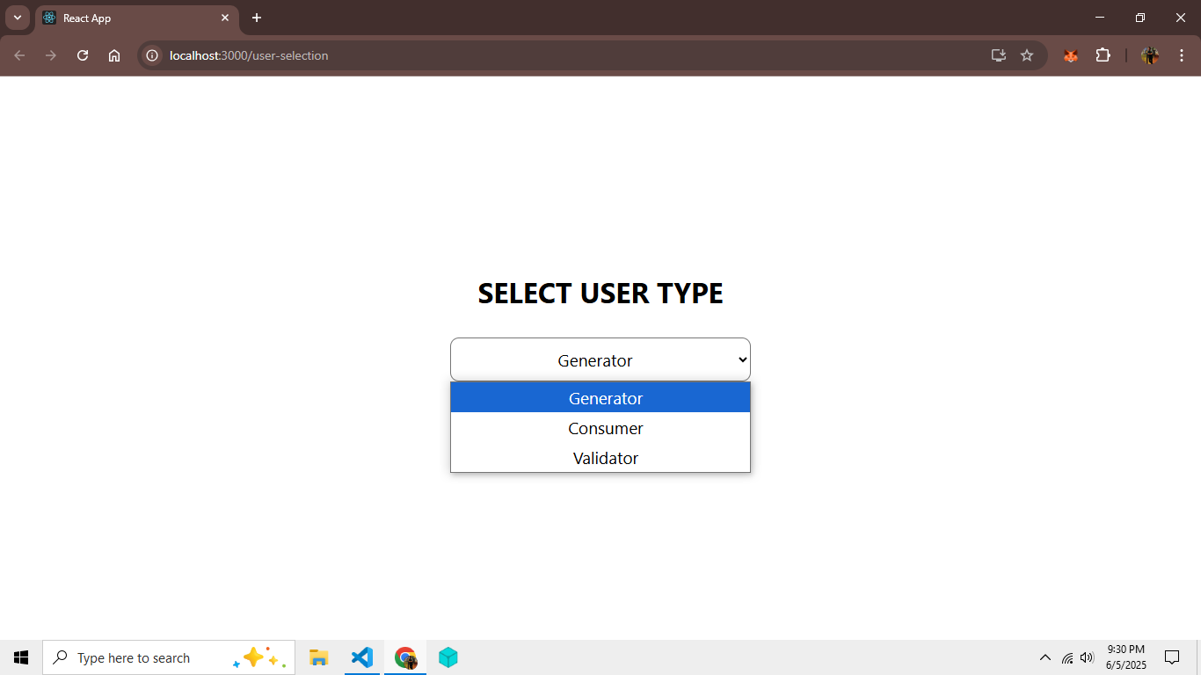

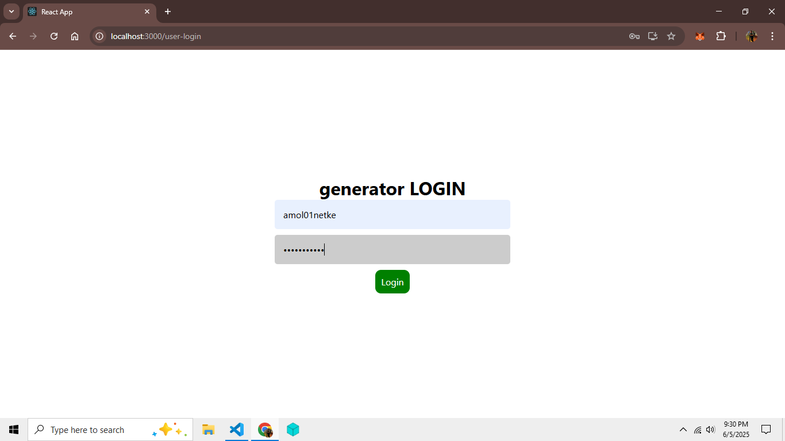

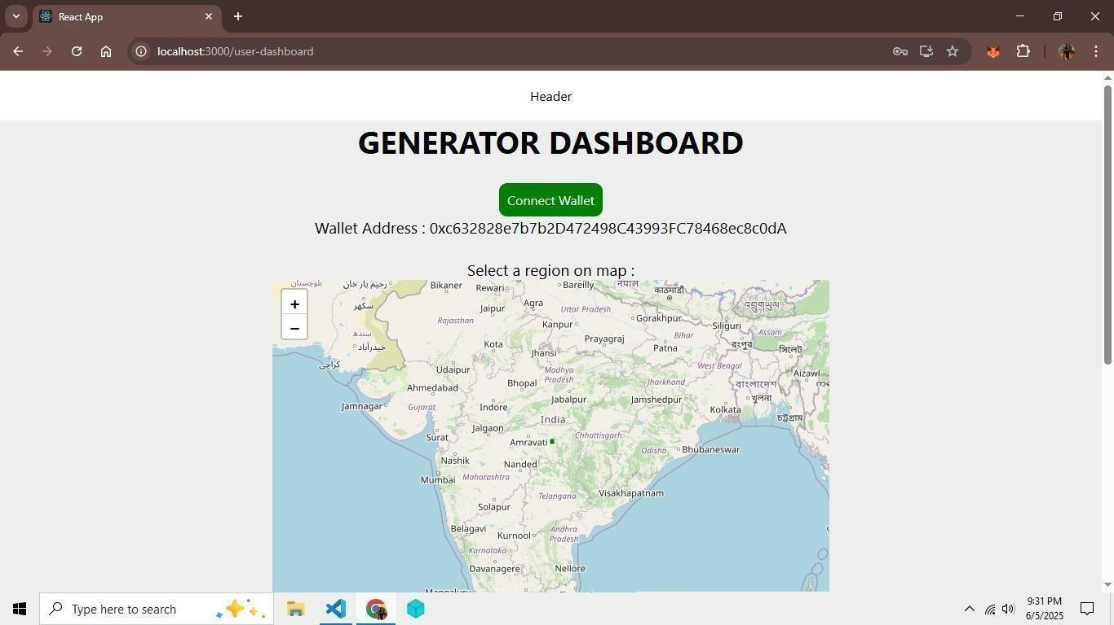

*The Generator selects a region on map and clicks on calculate NDVI. A request is sent to Sentinel Hub API which calculates the* ***NDVI (Normalized Difference Vegetation Index)*** *and this value is sent via websocket to Validator who verifies it*

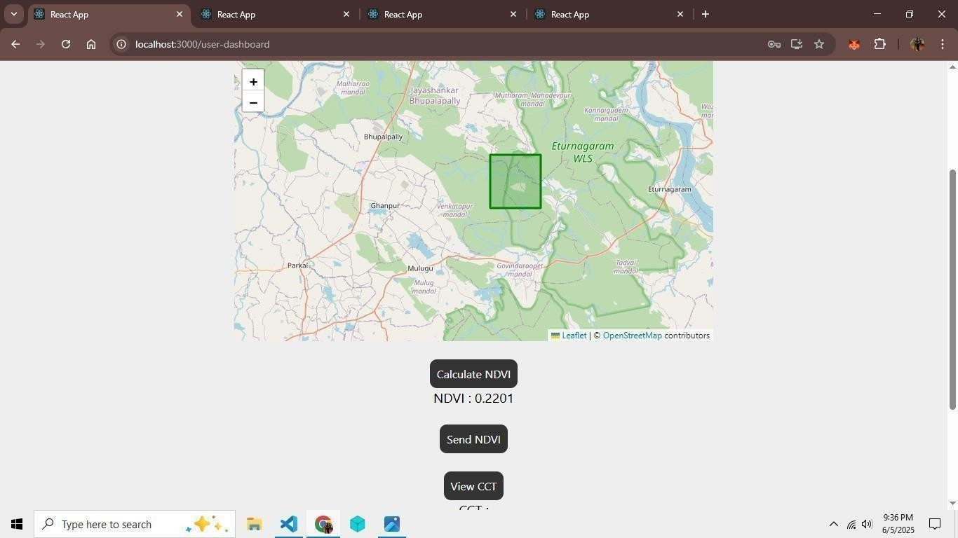

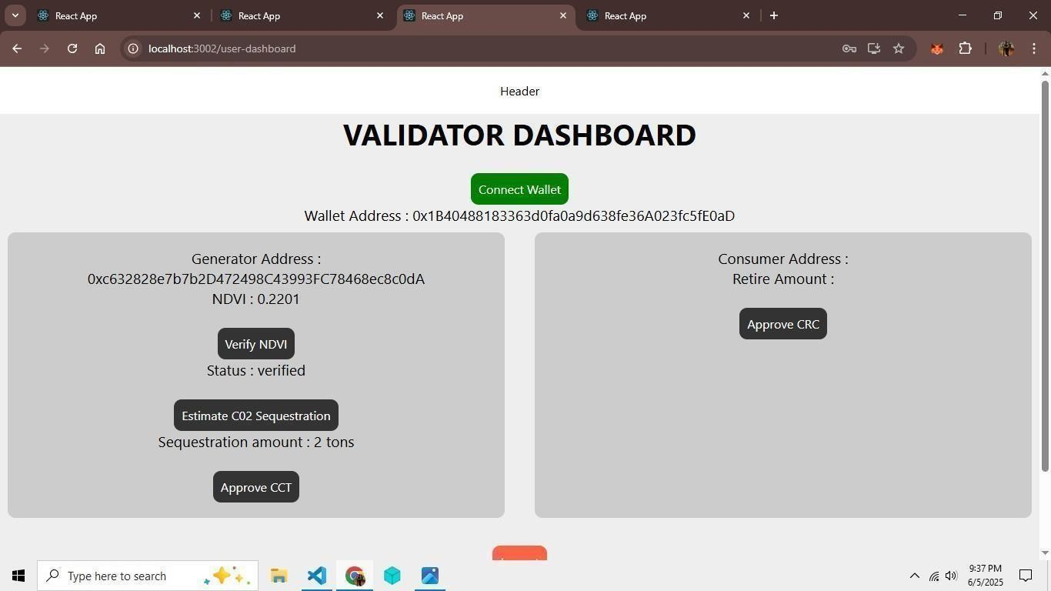

*Both the validators verify NDVI, estimate co2 and approve CCT which is credited to generator’s wallet via Smart Contract.*

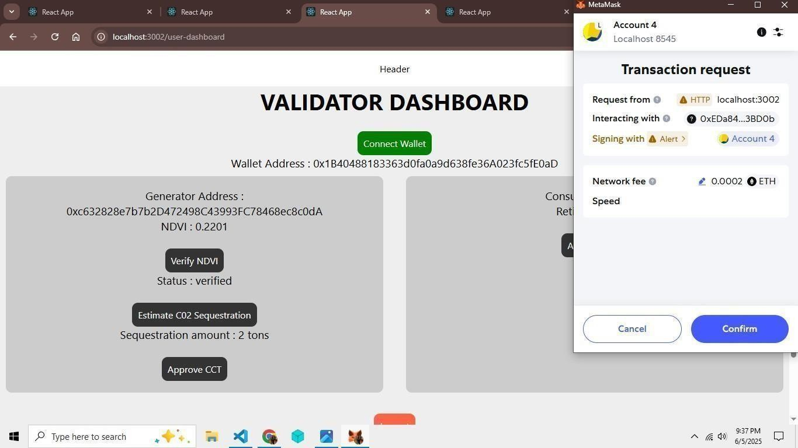

*This is buy/sell of the tokens between Generator and Consumer. The generator lists his tokens on AMM*

*i.e. Automated Market Maker. The consumer fetches the listings from AMM and selects a seller to buy CCT from. In the end, the consumer is credited with CCT and the generator is credited with respective ETH*

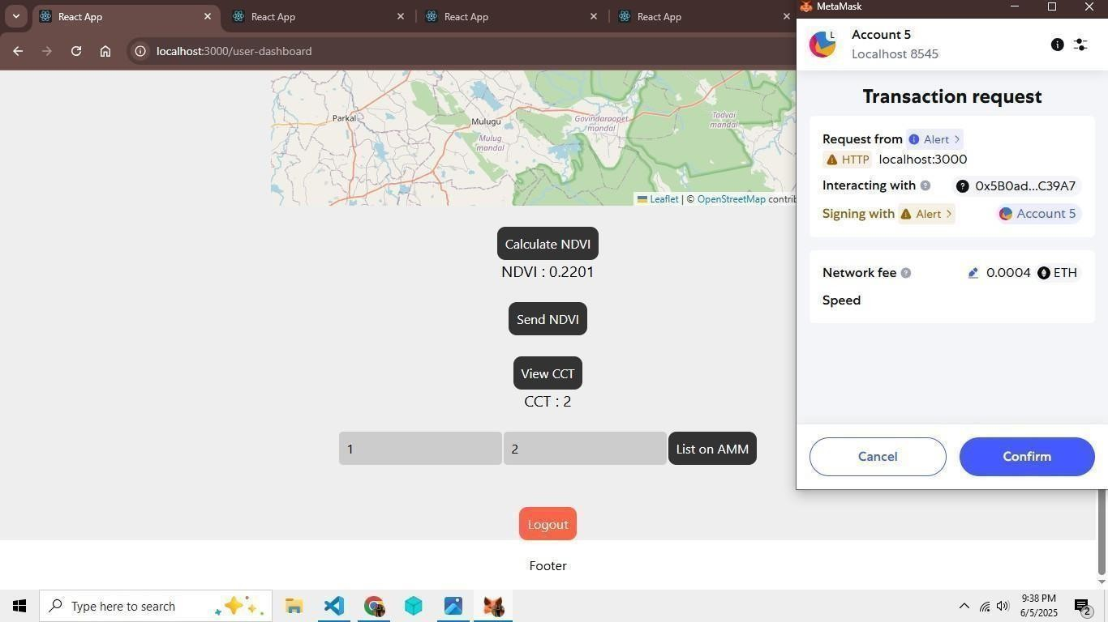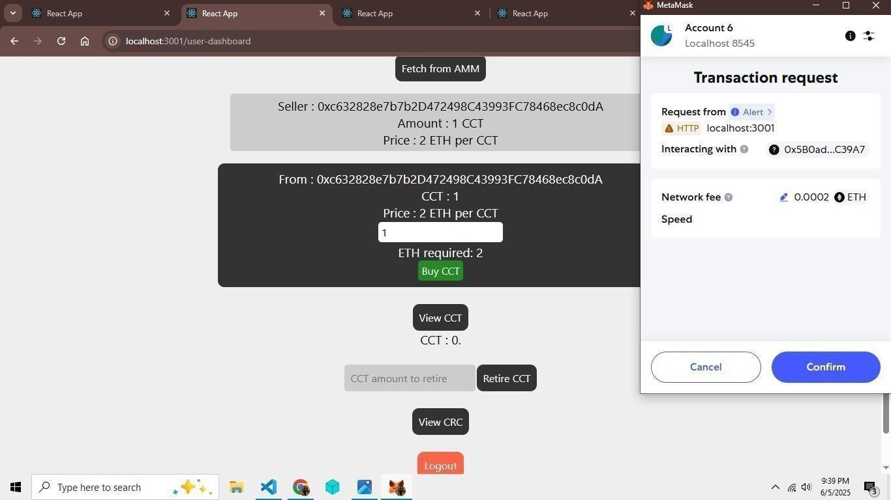

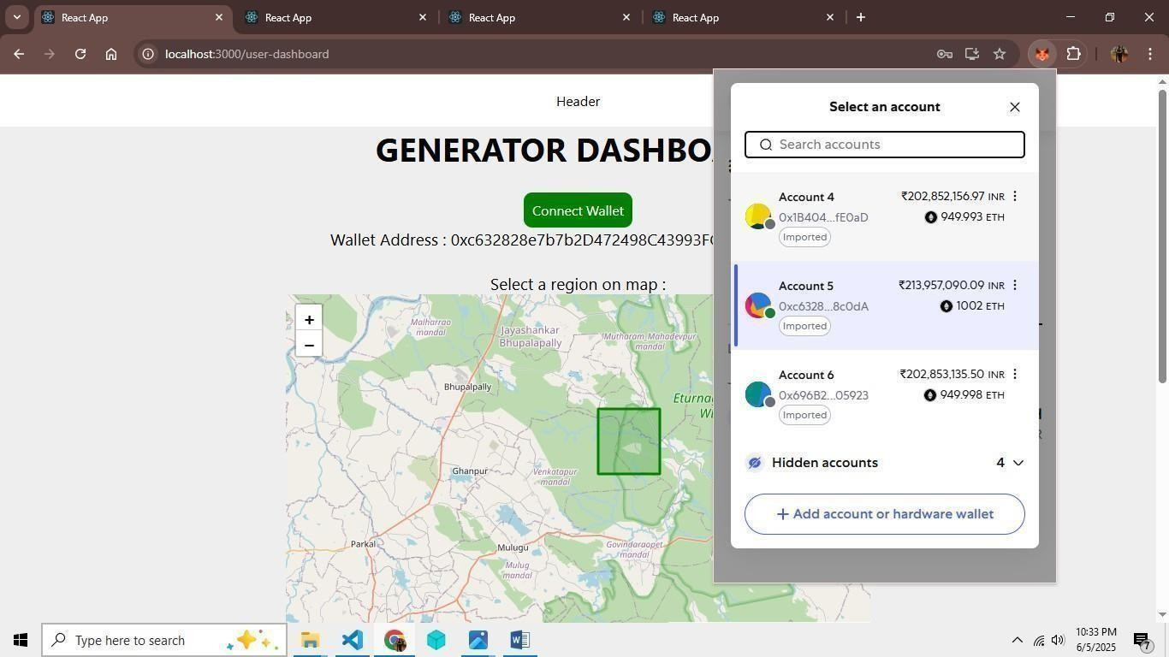

*In this, the consumer sends tokens to retire. The multi-validators approve it and the consumer is credited with* ***CRC i.e. Carbon Removal Certificate*.**

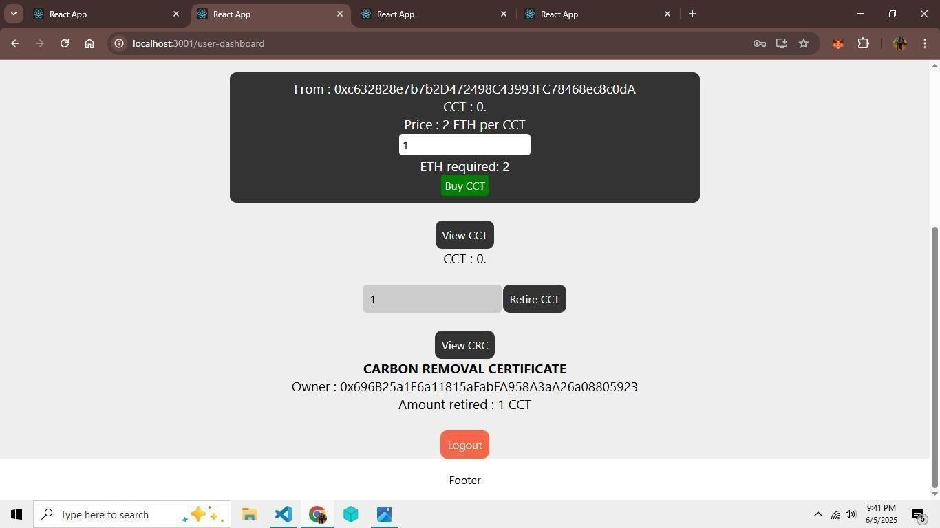

# SYSTEM TESTING

|  |  |  |  |
| --- | --- | --- | --- |
| **Test Case Description** | **Objective** | **Excepted Result** | **Obtained result** |
| *User login/ registration with email & password* | To confirm successful  user login/ registration | The user should be registered/logged in and redirected to the dashboard | The user is registered/ logged in and redirected to the dashboard |
| *MetaMask Wallet Connection* | To successfullyconnect MetaMask Wallets | The connected wallet address should be displayed ondashboard | The connected wallet address is displayed on dashboard |
| *NDVI Calculation via Sentinel Hub API* | To calculate NDVIof selected region | The NDVI value should be displayed on  screen | The NDVI value is displayed on screen |
| *Send NDVI for verification* | To send NDVI via  websocket | The validator should receive message on dashboard | The validator successfullyreceives a message on dashboard |
| *Verify NDVI & estimate co2 sequestration* | To verify NDVI via coordinates and update verification status and estimate co2 sequestration based on NDVI value | The generator and validator NDVI should match. The co2 estimation should differ for negative NDVI & psotive NDVI | The co2 estimation differs for negative and positive NDVI as well as the generator and validator NDVI matches |
| *Send CCT to generator* | To send CCT to generator | The generator’s wallet should be credited by CCT | The generator’s wallet is credited by CCT |

|  |  |  |  |
| --- | --- | --- | --- |
| *Trade CCT & ETH between consumerand generator* | To performcredit and debit of CCT & ETH between generator & consumer | The generator & consumer’s wallet & dashboard should show updated CCT & ETH values | The generator & consumer’s wallet & dashboard shows updated CCT & ETH values |
| *Logout* | To logout user from application | User should be logged out and returned to login page | User is successfully logged out and returned to login page |
| *Wallet Rejection / MetaMask Denied* | To test behavior when the user rejects wallet connection | User should be shown an error message and prevented from proceeding | Wallet rejection is handled and user is shown a proper error |
| *Invalid NDVI Coordinates* | To test submission of incorrect or out-of-bounds satellite coordinates | System should throw validation error and reject submission | Invalid input is rejected with an appropriate error message |
| *Unauthorized Validator Action* | Ensure that only registered validators can approve a project | Unauthorized validators should not be able to approve or interact with contracts | Access denied for unauthorized validator addresses |
| *Double Submission of Same NDVI* | To prevent duplicate NDVI project requests | System should check and prevent duplicate NDVI submissions | Duplicate submissions are blocked and alert is shown |
| *Add Liquidity to AMM Pool* | To test if liquidity provider can deposit tokens into AMM | Tokens should be deposited and liquidity updated; LP tokens might be issued | Liquidity added successfully, and pool reflects new state |
| *Remove Liquidity from AMM Pool* | To test if liquidity can be withdrawn | LP tokens should be burned and initial tokens returned with fees | Liquidity is removed and balance restored with accrued fee |

|  |  |  |  |
| --- | --- | --- | --- |
| *Retirement Certificate Verification* | To allow public/consumer to verify NFT details | NFT metadata (project, CO₂ retired, date) should be viewable | Metadata is accessible and verified |
| *Retirement History View* | To allow users to view their past retired credits | A list of retirement events and NFTs should be displayed | Retirement history is shown with NFT references |
| *System Behavior with No Internet (Frontend Only)* | To test offline mode frontend behavior | App should show warning or fallback handling when unable to connect | Network error message shown; blockchain functions are blocked |
| *Token Transfer Without Approval* | Prevent users from initiating CCT transfer without validation approval | Transaction should fail with smart contract error | Transaction is reverted and user is notified |
| *Direct Token Mint Attempt by Generator* | To ensure only validated projects can mint tokens | Unauthorized mint attempts should fail | Direct minting by generator is rejected |
| *CO₂ Estimation with Edge NDVI Values (-1 and +1 extremes)* | Validate CO₂ calculation logic with max/min NDVI | Results should show 0 or capped values depending on NDVI input | Output values are handled correctly without crashing |
| *Attempt to Burn Unowned CCT Tokens* | Prevent burning of tokens that user does not hold | Transaction should fail due to insufficient balance | Smart contract reverts and transaction fails |
| *Invalid Retirement Certificate Access* | Prevent viewing of NFTs that don't exist or aren't owned | System should show “not found” or “unauthorized” | NFT access is restricted and secure |

**Fig 6.1 Test Cases**

# ADVANTAGES & LIMITATIONS

## Advantages

### Transparency and Traceability

Blockchain provides an immutable and decentralized ledger where every action—right from project submission to credit retirement—is permanently recorded. This ensures that all stakeholders, including carbon credit buyers, regulators, and project developers, can audit and verify the full lifecycle of each carbon credit. The traceability of tokens not only ensures trust but also helps avoid issues like greenwashing, where false environmental claims are made for financial gain.

### Fraud Prevention and Double-Spending Protection

Traditional systems are often vulnerable to human error and fraud, including the issuance of fake or duplicate carbon credits. The use of multi-signature smart contracts in this system ensures that no carbon credit is issued without consensus from multiple trusted parties such as government bodies, NGOs, or validators. Additionally, since each token is uniquely identifiable and tracked on-chain, the possibility of double-spending is eliminated completely.

### Decentralization and Reduced Intermediaries

The use of smart contracts removes the need for traditional middlemen, such as brokers and third-party auditors. This leads to faster, cheaper, and more equitable carbon credit transactions. Moreover, decentralized validation ensures that no single authority can dominate or manipulate the system, promoting fairness and democratization of the carbon market.

### Real-time Data Integration

The integration of NDVI values from satellite imagery and associated project data into the system enables validators to make data-driven decisions. Rather than relying solely on manually submitted documents, validators can assess the environmental impact using scientific and up-to-date metrics. This results in more accurate and objective validations.

### Token Liquidity and Incentivized Trading

By integrating an Automated Market Maker (AMM), the system allows for decentralized trading of carbon credits, where the price is determined through a dynamic, supply-demand-based algorithm. Liquidity providers who stake tokens into the AMM are rewarded through transaction fees, promoting active participation and market fluidity.

### Immutable Retirement Certification

When a carbon credit is retired, the system mints a non-fungible token (NFT) as a certificate that cannot be altered or faked. This NFT contains critical metadata, including the amount of CO₂ offset, timestamp, and project details, providing permanent and verifiable proof of action. This adds an extra layer of accountability for companies claiming to be carbon neutral.

### Environmental Impact Verification

The platform uses satellite-backed NDVI (Normalized Difference Vegetation Index) data to verify actual carbon sequestration from land-based projects like reforestation. This scientific approach ensures that only genuinely impactful projects receive carbon credits, thereby reducing the risk of misleading or exaggerated environmental claims.

### Efficient Credit Issuance Workflow

From project submission by generators to credit issuance and retirement, the entire lifecycle is automated using smart contracts and backend services. This significantly reduces manual errors, processing time, and administrative overhead. It streamlines the workflow and allows for near real-time approvals and token distribution.

### Modular and Scalable Architecture

Built with a 3-tier architecture (frontend, smart contracts, off-chain DB), the system is designed to be modular, allowing future upgrades like DAO governance, dynamic pricing strategies, and new validator onboarding without disrupting the core workflow.

## Limitations

### Dependency on Internet and Blockchain Infrastructure

Since all on-chain activities require internet access and a live blockchain connection, the system may not be usable in remote or rural areas with poor connectivity. This becomes a significant issue for farmers or forest project developers who may not have consistent internet access, limiting platform inclusivity.

### Scalability Concerns on Public Blockchains

Public blockchains like Ethereum are often congested, leading to slow transaction times and high gas fees. This directly impacts user experience and can make micro-transactions economically unfeasible, especially when carbon credits are issued in small denominations. While Layer-2 solutions are being explored, this remains a bottleneck in real-world scaling.

### Off-chain Data Trust Issues

While off-chain databases like MongoDB are necessary to store large files (NDVI images, PDFs, documentation), they rely on the honesty and accuracy of validators for uploading data. Unless the off-chain data is cryptographically verified or further decentralized through IPFS or other protocols, there is a risk of tampering or misrepresentation.

### Regulatory Compliance and Legal Barriers

Carbon credit regulation is still evolving across various jurisdictions. The legal status of tokenized carbon credits may differ between countries, creating uncertainty for international trading.

Governments may also be hesitant to trust decentralized platforms without clear legal frameworks in place, slowing down adoption.

### User Accessibility and Technical Complexity

Blockchain-based platforms require users to interact with crypto wallets like MetaMask, understand gas fees, and manage private keys. This level of technical complexity may deter less tech-savvy users, particularly smallholder farmers or project developers from underdeveloped regions. User education and UI/UX simplification are necessary to bridge this gap.

# FUTURE SCOPE

As the global demand for effective carbon offset mechanisms grows, the **Blockchain-Based Carbon Credit Ecosystem** has significant potential for future development and impact. The following future enhancements are envisioned to ensure the platform’s long-term scalability, efficiency, and adoption across diverse sectors.

### Enhanced Scalability and Interoperability

To address transaction costs and performance bottlenecks on Layer-1 networks, the system will integrate **Layer-2 scaling solutions** such as **zkSync** and **Optimism**. These solutions utilize rollups to bundle and compress transaction data, significantly reducing gas fees while maintaining Ethereum- level security.

Furthermore, **cross-chain interoperability** will be established with popular blockchain networks like **Polygon**, **Avalanche**, and **Binance Smart Chain (BSC)**. This integration will enable users to move tokens and interact across ecosystems, promoting broader market participation and ensuring compatibility with various **DeFi** platforms and decentralized exchanges (DEXs).

By supporting multi-chain architecture, the platform will become more accessible to users from different blockchain environments, ultimately encouraging mass adoption and decentralized finance (DeFi) integration.

### Intelligent Verification Systems

To enhance the reliability of carbon credit issuance, the system will integrate **AI-driven verification mechanisms**. These intelligent systems will automatically detect inconsistencies, fraudulent submissions, or duplicate entries by analyzing project metadata, geospatial information, and historical patterns.Machine learning models will continuously learn from validator decisions and field data, refining the accuracy of credit assessments.

The platform will also ingest **real-time environmental data** from **IoT sensors**, **weather APIs**, and **remote sensing satellites** such as **Sentinel-2**, allowing for automated NDVI calculations and dynamic credit generation.

This automation will significantly reduce human error, expedite the verification timeline, and scale the process for larger user bases.

### Decentralized Governance Framework

The system aims to evolve into a **community-governed DAO (Decentralized Autonomous Organization)**. DAO participants—including validators, NGOs, researchers, and carbon market experts— will have voting rights to propose and approve changes related to platform upgrades, validator onboarding, and fee structures.

In addition, **smart contract-based compliance tools** will be introduced to ensure adherence to internationally recognized standards such as **Verra**, **Gold Standard**, and region-specific environmental regulations. These tools will act as automated policy enforcement agents, making the platform adaptable to varying legal frameworks while maintaining its decentralized ethos.

This governance model will increase community engagement, foster trust, and ensure long-term decentralization.

### Expanded User Engagement Features

To reach a wider audience and encourage everyday climate action, the platform will introduce **mobile applications** with user-friendly interfaces. These apps will include **gamified features** such as achievements for offsetting milestones, leaderboards for top contributors, and educational quizzes related to sustainability and carbon markets.

Further, strategic partnerships with **e-commerce**, **food delivery**, and **travel platforms** will be pursued to integrate **carbon offsetting directly into user purchase flows**. For instance, customers can choose to offset the carbon footprint of their flight or online order during checkout, with real-time certificate generation and traceability.

Such integrations will normalize carbon neutrality in daily life and empower users to make climate- conscious decisions.

### Innovative Financial Instruments

The future roadmap includes the development of **specialized marketplaces** for **carbon credit NFTs**. These NFTs will not only serve as proof of carbon retirement but also represent **unique environmental projects**, such as reforestation efforts or renewable energy initiatives. These project-based NFTs will attract eco- conscious investors and collectors.

Moreover, a **crowdfunding mechanism** using **tokenized future carbon credits** will be introduced. This will allow individuals and institutions to invest in early-stage sustainability projects and receive returns in the form of carbon tokens once the project begins delivering measurable offsets.

Such instruments will open new financial pathways for green investment, create liquidity for environmental projects, and democratize access to climate finance.

# CONCLUSION

The **Blockchain-Based Carbon Credit Ecosystem** offers a groundbreaking alternative to conventional carbon markets by utilizing Ethereum smart contracts, ERC token standards, and Automated Market Makers (AMMs) to fully automate and increase transparency throughout the carbon credit lifecycle—from initial issuance and validation to trading and final retirement. Through the integration of a robust multi-signature verification mechanism and fractional tokenization, the platform ensures that all carbon credits are fraud-resistant and governed in a decentralized manner. Its hybrid architecture, combining on-chain smart contracts with off-chain storage using MongoDB, addresses scalability challenges while maintaining data integrity and privacy. Comprehensive testing on Ethereum test networks demonstrates significant enhancements in transaction speed, transparency, and user control compared to traditional systems. Furthermore, planned advancements such as Layer-2 scaling solutions, AI-powered fraud detection, and alignment with leading regulatory frameworks like Verra and Gold Standard will strengthen compliance and foster greater adoption. Together, these innovations position the ecosystem as a scalable, future-ready solution aimed at democratizing carbon finance, accelerating environmental impact, and driving global sustainability initiatives forward.

# REFERENCES

1. M. Andoni et al., "Blockchain technology in the energy sector: A systematic review of challenges and opportunities," *Renew. Sustain. Energy Rev.*, vol. 100, pp. 143–174, 2019.
2. S. Kim and J. Huh, "Blockchain of carbon trading for UN sustainable development goals,"

*Sustainability*, vol. 12, no. 10, p. 4021, 2020.

1. F. Luo and K. Gai, "A distributed electricity trading system in active distribution networks based on multi- agent coalition and blockchain," *IEEE Trans. Ind. Informat.*, vol. 16, no. 8, pp. 5046– 5054, 2020.
2. S. Wang and J. Yu, "Energy crowdsourcing and peer-to-peer energy trading in blockchain- enabled smart grids," *IEEE Trans. Ind. Informat.*, vol. 17, no. 6, pp. 3564–3572, 2021.
3. S. Zubair and F. Khan, "Exploring the potential of blockchain technology for carbon emissions reduction: A review," *J. Clean. Prod.*, vol. 263, p. 121365, 2020.
4. Y. Zhang and J. Li, "Blockchain-based carbon trading platform: A new approach for sustainable energy transition," *Energies*, vol. 15, no. 4, p. 1312, 2022.
5. S. Pahl and P. Grefen, "Blockchain technology for sustainable carbon markets: A review of challenges and opportunities," *Sustainability*, vol. 12, no. 11, p. 4622, 2020.
6. A. Sutherland and Z. Zhou, "The role of blockchain in enhancing the transparency of carbon credit markets,"

*Environ. Sci. Policy*, vol. 121, pp. 64–73, 2021.

1. J. Rojas and P. Jha, "The impact of blockchain on carbon credit trading systems: An analysis of market efficiency," *Energy Econ.*, vol. 112, p. 105894, 2023.
2. A. Yadav and R. Yadav, "Leveraging blockchain technology for carbon credits: Opportunities and challenges," *J. Environ. Manage.*, vol. 267, p. 110624, 2020.

****International Journal for Research in Applied Science & Engineering Technology (IJRASET**)**

*ISSN: 2321-9653; IC Value: 45.98; SJ Impact Factor: 7.538*

*Volume 13 Issue I Jan 2025- Available at* [*www.ijraset.com*](http://www.ijraset.com/)

**Blockchain-Based Carbon Credit Ecosystem**

Amol S. Netke1, Yogesh M. Zade2, Yuvrajsing G. Solanke3, Harsh S. Satwani4

*Department of Information Technology, Dr. D. Y. Patil College of Engineering, Akurdi, Pune, 411044*

***Abstract: Climate change and global warming demand immediate action, and a global carbon trading system can help by reducing greenhouse gas emissions. Carbon credits allow companies to emit a defined amount of carbon dioxide, with each credit typically equaling one ton. Although these credits incentivize emissions reduction, current systems lack transparency, face high transaction costs, and benefit intermediaries. Our project proposes a blockchain-based Carbon Credit Ecosystem that uses blockchain and smart contracts to create a more transparent, accessible, and efficient carbon market. This system will tokenize carbon credits, establish protocols for credit creation and retirement, and transparently manage trading. Engaging stakeholders like the energy sector, project verifiers, NGOs, citizens, and governments, our model provides broad benefits and is adaptable to other credit and trading systems. Keywords: Blockchain, Carbon Credit, Smart Contracts, Carbon Trading, Transparency***

* 1. **INTRODUCTION**

With rising carbon emissions globally, there is an urgent need for a secure, transparent, and efficient carbon credit system. Traditional carbon credit mechanisms face significant challenges, including lack of transparency, risks of double-counting, high transaction costs, and fragmentation across regulatory environments. Our project aims to address these challenges by creating a Blockchain-Based Carbon Credit Ecosystem, leveraging blockchain technology to ensure the integrity and authenticity of carbon credits through immutable records and decentralized verification. This decentralized system uses smart contracts to automate the issuance, trading, and retirement of carbon credits, effectively reducing fraud and mismanagement risks.

The proposed platform provides transparency at each step of the carboncredit lifecycle—from issuance through trading and etirement while enhancing accessibility and lowering transaction costs by reducing reliance on intermediaries. Our objectives include establishing standardized protocols for tokenizing, minting, and burning carbon credits, and implementing a decentralized market with an automated market maker (AMM) to promote liquidity and price stability. This accessible, user-friendly system encourages diverse participation from stakeholders, including businesses, NGOs, and individuals, fostering global engagement in carbon markets. By aligning with international sustainability goals, this platform supports a broader effort toward reducing global greenhouse gas emissions and combating climate change.

* 1. **RELATED WORK**

Numerous studies have explored blockchain’s potential to improve transparency, efficiency, and scalability in carbon credit ecosystems, a critical need in the global effort to reduce greenhouse gas emissions. Dr. Soheil Saraji and Dr. Mike Borowczak addressed this by proposing a blockchain-based ecosystem that digitizes carbon credits and employs smart contracts to reduce transaction costs, prevent issues like over-crediting, and streamline carbon credit trading, though their model faces challenges in achieving global scalability and integrating with established carbon markets and diverse stakeholders. Similarly, Dr. Surekha Deshmukh’s research investigated the use of blockchain in the energy transition, particularly in decarbonization initiatives. Her study emphasized blockchain’s role in peer-to-peer trading, smart contracts, and grid optimization, which can enhance transparency and accountability within the energy sector’s decarbonization process. While her findings were promising, Deshmukh recommended improving data governance and stakeholder integration to maximize blockchain’s impact, along with the development of advanced AI models to optimize both market and operational efficiencies. Additionally, a study by Infosys Limited addressed the fragmented nature of carbon credit markets, advocating for a blockchain-powered, unified, and transparent platform that could facilitate the issuance, trading, and lifecycle tracking of carbon credits. By reducing dependence on intermediaries, this approach could standardize carbon credit pricing, improve transparency, and decrease transaction costs; however, the study also pointed to the need for further integration with IoT and AI to enhance data accuracy and simplify complex audit processes. Finally, Seong-Kyu Kim and Jun-Ho Huh’s work focused on a blockchain application designed to track and verify carbon credits in alignment with the UN Sustainable Development Goals (SDGs), suggesting the use of AI and big data for anomaly detection and transaction verification to reduce fraud and increase transparency. Despite the benefits of a blockchain-based verification system,

33

34

****International Journal for Research in Applied Science & Engineering Technology (IJRASET**)**

*ISSN: 2321-9653; IC Value: 45.98; SJ Impact Factor: 7.538*

*Volume 13 Issue I Jan 2025- Available at* [*www.ijraset.com*](http://www.ijraset.com/)

Together, these studies underscore blockchain’s potential to revolutionize carbon credit systems by fostering transparency, reducing fraud, and enabling efficient, secure transactions across various regulatory and market environments.

* 1. **PROBLEM STATEMENT**

1. *Problem Statement*

To develop a decentralized blockchain-based carbon credit system that ensures transparent, secure, and efficient tracking and trading of carbon credits, reducing fraud and costs while promoting trust and sustainability through automated processes.

1. *Description*

The current carbon credit systems are plagued by several critical issues that hinder their effectiveness in combating climate change. These systems suffer from fragmentation, with various regions and platforms adopting inconsistent standards and practices, which complicates the verification and comparison of carbon credits. This lack of uniformity reduces trust in the system and obstructs global efforts to standardize carbon trading. Furthermore, the absence of transparency in the issuance and trading processes leads to problems such as over-crediting and double spending, further undermining the credibility of these systems. Without clear and transparent processes, stakeholders find it difficult to audit or verify the authenticity of carbon credits, which fosters skepticism and diminishes participation. Additionally, high transaction costs are a major barrier, as the involvement of multiple intermediaries drives up expenses, reducing the financial incentives for individuals and companies to engage in carbon credit trading. These costs often benefit intermediaries rather than advancing environmental sustainability. To tackle these challenges, the proposed Blockchain-Based Carbon Credit Ecosystem leverages blockchain technology to create a standardized, transparent, and efficient platform. By utilizing smart contracts and decentralized ledgers, this ecosystem ensures the integrity and authenticity of carbon credits through immutable records and decentralized verification processes. The system will automate the issuance, trading, and retirement of carbon credits, minimizing the risks of fraud, double-counting, and mismanagement. This approach will reduce transaction costs, improve accessibility, and encourage wider participation, ultimately making carbon markets more effective in achieving global greenhouse gas reduction goals.

* 1. **PROPOSED SYSTEM**

The proposed system aims to create a decentralized Blockchain-based Carbon Credit Ecosystem to enhance liquidity, transparency, accessibility, and standardization in carbon markets. It integrates stakeholders, including generators, consumers, and validators, into a unified platform. Key features include a Tokenization Mechanism for minting and burning carbon tokens, Transparent Distribution to ensure fair allocation of tokens, and an Automated Market Maker (AMM) for decentralized trading based on supply and demand. The system involves Generators (such as wind farms and reforestation projects), Consumers (industries offsetting emissions), and Validators (experts ensuring the legitimacy of credits). The workflow includes Tokenization (digitizing carbon credits into blockchain tokens), Trading Platform (a decentralized exchange for trading tokens), and Burning Mechanism (retiring tokens via a "buy and burn" model, with rewards in the form of non-fungible tokens, or NFTs).

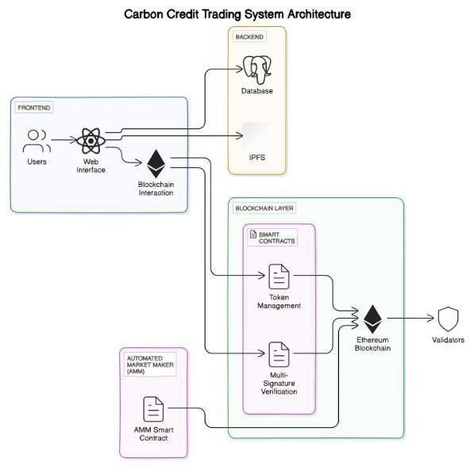

****International Journal for Research in Applied Science & Engineering Technology (IJRASET**)**

*ISSN: 2321-9653; IC Value: 45.98; SJ Impact Factor: 7.538*

*Volume 13 Issue I Jan 2025- Available at* [*www.ijraset.com*](http://www.ijraset.com/)

Technology Stack

1. Frontend Framework – React.js
2. Web3 integration – Web3.js or Ethers.js
3. Styling – Bootstrap and Material UI
   1. *Smart Contracts*

The system utilizes four keysmart contracts, each designed to automate specific processes and interact with stakeholders.

Smart Contract 1: Registry System records essential information about stakeholders, such as verifiers, credit-holders, and customers, ensuring that carbon credits are properly registered and tracked within the ecosystem. Smart Contract 2: Token Management manages the approval and minting of carbon tokens, ensuring that only verified carbon credits are converted into tokens, while also facilitating their transfer and burning. NFTs are issued as certificates for successfully retired carbon tokens. Smart Contract 3: Multi-Signature Verification oversees the minting and burning process, requiring approval from at least 70% of verifiers before execution to maintain the integrity and legitimacy of transactions. Smart Contract 4: Automated Market Maker (AMM) automates the trading of carbon tokens against digital currencies, such as stablecoins or potential future central bank digital currencies (CBDCs). It incentivizes liquidity providers by sharing transaction fees (e.g., 0.3%) and dynamically adjusts the price of carbon tokens based on market activity.

* 1. *Frontend*

The frontend of the Blockchain-based Carbon Credit Ecosystem offers a user-friendly interface for all stakeholders to engage with the system. It features a User Dashboard, providing a centralized view of user activities, including carbon credits, tokens, and transactions, along with notifications for important updates. Carbon Credit Management interfaces allow carbon credit generators to submit projects and enable buyers and sellers to participate in token trading, while tools for tracking market trends and transaction history are also available. Verification and Validation dashboards allow validators to review and approve carbon credits, ensuring transparency in the verification process, with an audit trail to track verification activities. The system integrates with the Marketplace Interaction feature for trading carbon tokens and viewing liquidity pools, facilitated by the AMM. Security Features ensure the protection of user information through secure login protocols, multi-factor authentication (MFA), and data encryption.

* 1. **HIGH LEVEL DESIGN**

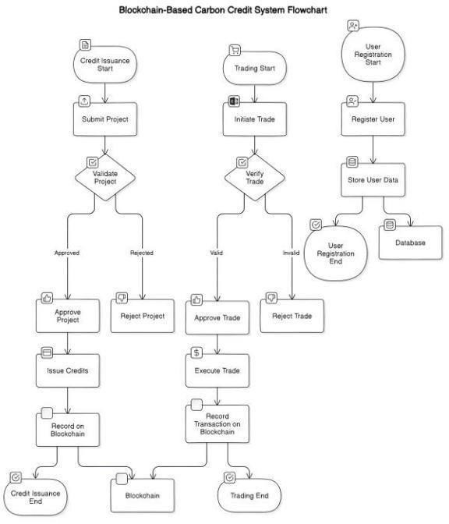The high-level design of the Blockchain-based Carbon Credit Ecosystem focuses on creating a decentralized, transparent, and efficient platform for carbon credit trading. The system integrates stakeholders such as carbon credit generators, consumers, and validators into a unified platform. Key components include tokenization for digital representation of carbon credits, automated market mechanisms for dynamic trading, and smart contracts for automating processes like credit approval, token minting, and verification. The user-friendly frontend allows stakeholders to manage carbon credits, track transactions, and engage in trading, while secure features ensure data protection. This design ensures enhanced liquidity, fairness, and scalability in carbon credit markets.

35

36

****International Journal for Research in Applied Science & Engineering Technology (IJRASET**)**

*ISSN: 2321-9653; IC Value: 45.98; SJ Impact Factor: 7.538*

*Volume 13 Issue I Jan 2025- Available at* [*www.ijraset.com*](http://www.ijraset.com/)

* 1. **UML DIAGRAM AND SYSTEM WORKFLOW**

The UML diagram below illustrates the overall architecture and workflow of the Blockchain-based Carbon Credit Ecosystem. It visualizes the interactions between key components such as stakeholders, smart contracts, and the trading platform. The diagram highlights the flow of carbon credit tokens from generation and verification through to trading and retirement, ensuring transparency, accountability, and efficiency. It serves as a comprehensive representation of how the system operates, showcasing the seamless integration of tokenization, automated market mechanisms, and verification processes within the ecosystem.

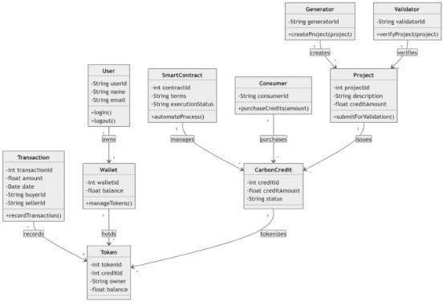

* 1. **SYSTEM IMPLEMENTATION**

The implementation of the Blockchain-Based Carbon Credit Ecosystem addresses key challenges in the current carbon credit market by utilizing blockchain technology, smart contracts, and user-friendly applications to enhance the integrity, transparency, and efficiency of carbon credit transactions, thereby supporting global sustainability efforts. The process begins by setting up the blockchain environment, including the installation of the Ethereum development framework (e.g., Truffle or Hardhat) and deploying smart contracts to the Ethereum test network. The web interface is developed using React.js, while React Native is used to build mobile applications for both Android and iOS. Integration of smart contracts is achieved through web3.js, enabling interaction with the deployed contracts for functions like issuing, trading, and retiring carbon credits. Comprehensive testing is carried out, including unit testing of smart contracts using tools like Mocha and Chai, as well as end-to-end testing for both web and mobile applications. Finally, the web application is deployed on cloud platforms like AWS or Heroku, and the mobile application is published on major app stores such as Google Play Store and Apple App Store.

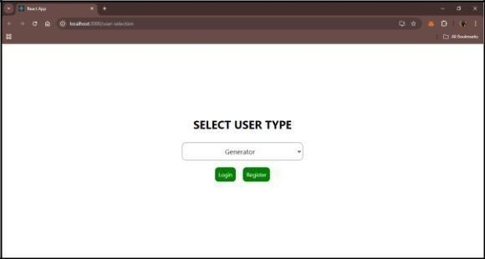

****International Journal for Research in Applied Science & Engineering Technology (IJRASET**)**

*ISSN: 2321-9653; IC Value: 45.98; SJ Impact Factor: 7.538*

*Volume 13 Issue I Jan 2025- Available at* [*www.ijraset.com*](http://www.ijraset.com/)

User Selection page from where we can select the user type to get login with.

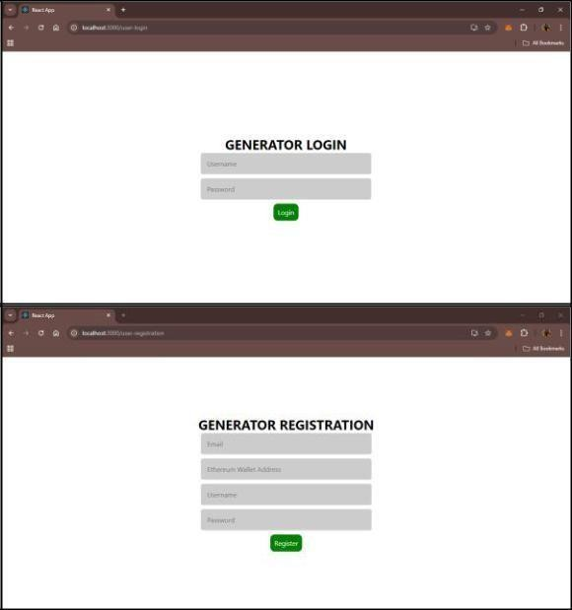

The output images showcase the user interface (UI) for selecting the user type—Generator, Consumer, or Validator—ensuring a seamless flow for different stakeholders in the Blockchain-Based Carbon Credit Ecosystem. Upon selecting the "Generator" user type, the next images display the login and registration UI, designed to allow carbon credit generators to securely register and log in to the platform, enabling them to submit their emission reduction projects. These UI screens are intuitive and tailored to facilitate easy access for generators to engage with the carbon credit ecosystem.

* 1. **FUTURE SCOPE**

The future scope of the Blockchain-Based Carbon Credit Ecosystem holds significant potential for further enhancing the effectiveness and scalability of global carbon markets. As blockchain technology continues to evolve, integrating advanced solutions such as artificial intelligence (AI) for improved carbon credit verification and machine learning (ML) for dynamic pricing and risk analysis could provide more accurate and efficient decision-making. Additionally, expanding the ecosystem to include more diverse carbon offset projects, such as those targeting biodiversity and water conservation, would further diversify carbon credit offerings. Collaborations with governmental bodies and international organizations could also promote standardization and global adoption, making the system a cornerstone in the fight against climate change.

* 1. **CONCLUSION**

The Blockchain-Based Carbon Credit Ecosystem represents a significant advancement in the way carbon credits are managed and traded. By leveraging blockchain technology, the project aims to create a more transparent, efficient, and trustworthy system for carbon offsetting. The ecosystem addresses key challenges in the current market, such as the lack of transparency, inefficiencies in verification processes, and the potential for fraud. Through this project, stakeholders will benefit from a decentralized and secure platform that automates the lifecycle of carbon credits, from issuance to retirement. The integration of IoT devices and data oracles ensures real-time and accurate monitoring of environmental impact, enhancing the credibility of carbon credits. Moreover, the decentralized marketplace will foster greater market liquidity and allow for peer-to-peer trading, reducing transaction costs and barriers to entry.

**REFERENCES**

1. Andoni, M., Robu, V., Flynn, D., Abram, S., Geach, D., Jenkins, D., & Peacock, A. (2019). Blockchain technology in the energy sector: A systematic review of challenges and opportunities. Renewable and Sustainable Energy Reviews, 100, 143-174.
2. Kim, S., & Huh, J. (2020). Blockchain of Carbon Trading for UN Sustainable Development Goals. Sustainability, 12(10), 4021.

37

****International Journal for Research in Applied Science & Engineering Technology (IJRASET**)**

*ISSN: 2321-9653; IC Value: 45.98; SJ Impact Factor: 7.538*

*Volume 13 Issue I Jan 2025- Available at* [*www.ijraset.com*](http://www.ijraset.com/)

1. Wang, S., & Yu, J. (2021). Energy Crowdsourcing and Peer-to-Peer Energy Trading in Blockchain-Enabled Smart Grids. IEEE Transactions on Industrial Informatics, 17(6), 3564-3572..
2. Zubair, S., & Khan, F. (2020). Exploring the potential of blockchain technology for carbon emissions reduction: A review. Journal of Cleaner Production, 263, 121365.
3. Zhang, Y., & Li, J. (2022). Blockchain-based carbon trading platform: A new approach for sustainable energy transition. Energies, 15(4), 1312.
4. Pahl, S., & Grefen, P. (2020). Blockchain technology for sustainable carbon markets: A review of challenges and opportunities. Sustainability, 12(11), 4622.
5. Sutherland, A., & Zhou, Z. (2021). The role of blockchain in enhancing the transparency of carbon credit markets. Environmental Science & Policy, 121, 64- 73.
6. Rojas, J., & Jha, P. (2023). The impact of blockchain on carbon credit trading systems: An analysis of market efficiency. Energy Economics, 112, 105894.
7. Yadav, A., & Yadav, R. (2020). Leveraging blockchain technology for carbon credits: Opportunities and challenges. Journal of Environmental Management, 267, 110624.
8. Rejeb, A., & Rejeb, K. (2022). Blockchain technology for carbon footprint tracking: A systematic review. Journal of Cleaner Production, 333, 130107.
9. Dimitrov, S. (2022). Blockchain for carbon management: A decentralized approach to carbon trading. Computers & Chemical Engineering, 156, 107401.
10. Farahani, R. Z., & Khosravi, A. (2021). A blockchain-enabled framework for carbon trading: Challenges and prospects. Sustainable Cities and Society, 74, 103201.
11. Bhatia, M., & Malik, V. (2022). Blockchain as a tool for achieving sustainability in carbon credit trading: An analytical framework. Environmental Science and Pollution Research, 29(6), 8438-8454.

**ICCSS Certification**

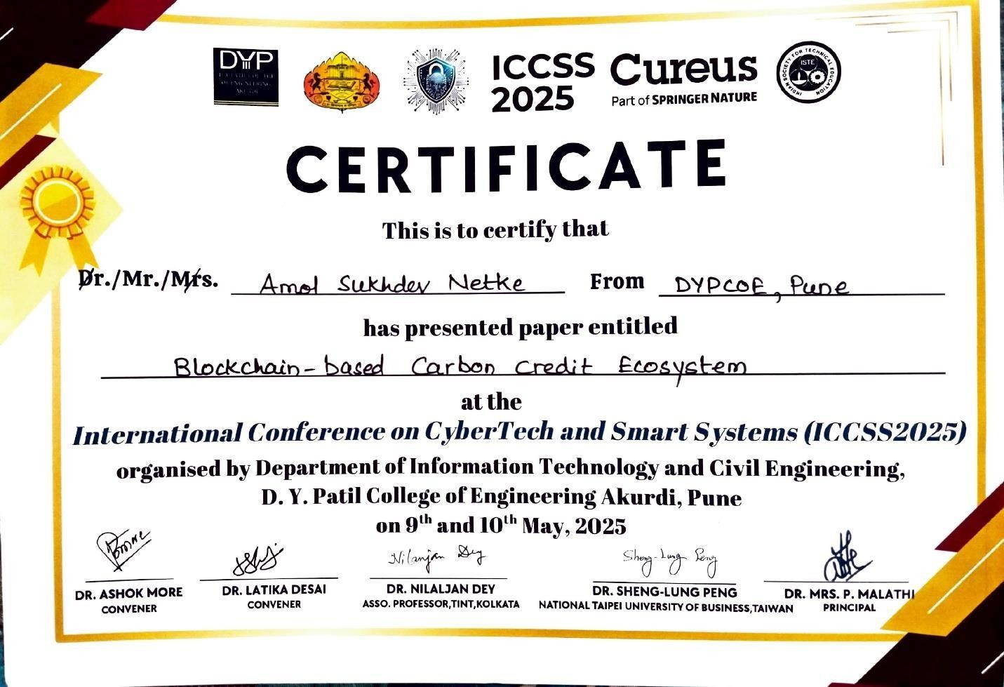

**Plagiarism Report**

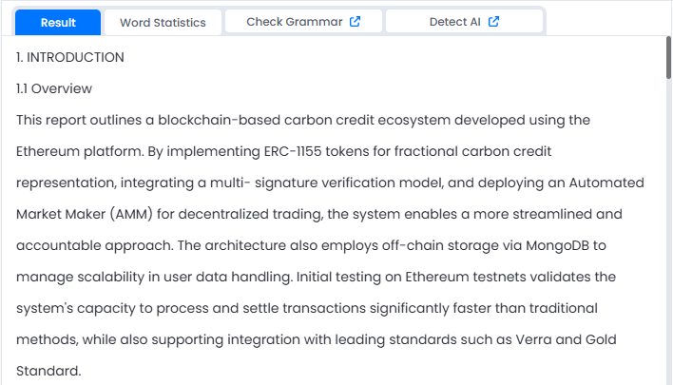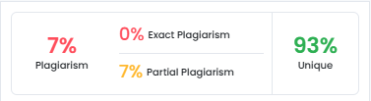

*Plagiarism Checker : https://smallseotools.com/plagiarism-checker/*